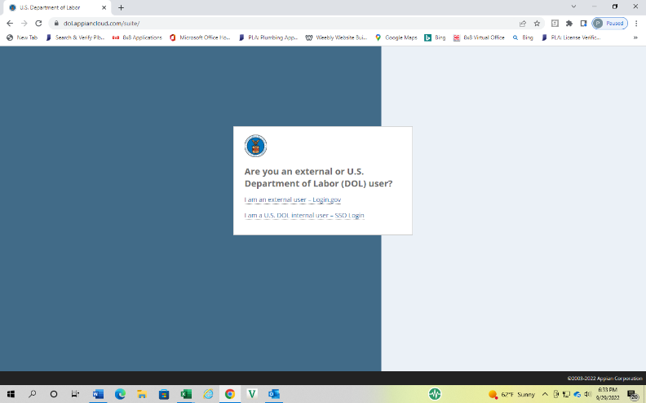
https://dol.appiancloud.com/suite
After entering the above website, you will arrive at this screen.
Select that you are an “external user.”

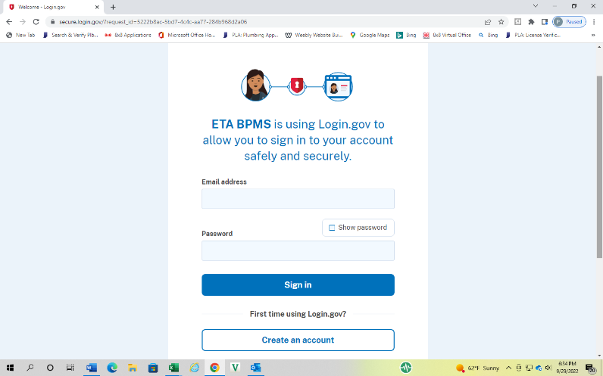
Next, you will be directed to the Log In screen. If this is your first time registering an apprentice, select “Create an Account.”

If you have registered apprentices in the RAPIDS system before, use your saved login information to enter the site. From your home page you will be able to add a new apprentice and generate their apprenticeship agreement. (Form ETA 671)

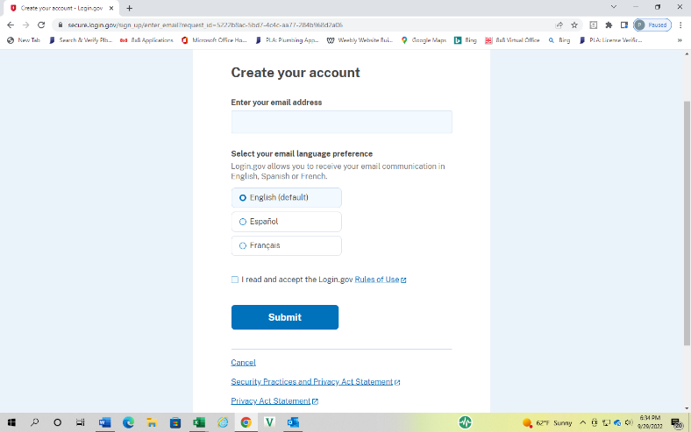
If you are a first-time user, create a login and password. Save your login information! Follow the prompts. Your first step will be to register your business. Once you have entered all of your company’s information, you will be able to add an apprentice and assign them to the licensed contractor that will be their mentor.
The final step will be to generate a printable apprenticeship agreement. (Form ETA 671).

The apprenticeship agreement will print as a five-page document. Only the first three pages are needed. On page three, both the apprentice and mentor contractor must sign. You will find in Part D that the name of a Dept. of Labor representative has been auto populated. That certifies that your agreement was registered properly.

